HARVEST ASSIST app with even more functions
HARVEST ASSIST, Pöttinger's innovative app for optimising forage harvesting, is constantly being expanded. It now features three new functions for optimising the deployment of harvest machines to further boost harvesting performance. Available for iOS and Android, every member of the harvest convoy can install the app on their smartphone for free. The new functions are available starting April 2024.

In the HARVEST ASSIST app, you can select any of the machines in your harvest fleet: You can choose from mowers, tedders, rakes, mergers, loader wagons and round balers. The app makes it easy to add fields and assign them to each of the machines. It gives everyone involved a real-time overview of progress in the field and the current status of each machine. The compaction vehicle at the clamp has time to neatly distribute and compact each load of crop one by one.

The new functions
Number of bales in the field: In the app, the baler driver can enter the number of bales deposited in each field. The drivers of the loaders and bale collection vehicles can see at a glance how many bales need to be fetched.
If there are several bale collection teams, each driver knows immediately which fields they still need to visit and how many bales have already been removed. The number of bales also provides an indication of the harvesting performance. This enables you to keep track of the grass and whole crop harvest at any time.

Navigating to the clamp: In addition to providing navigation to the field, the navigation function also shows the route back to the clamp. A new clamp can be added and navigated to directly using Google Maps. This latest feature in the HARVEST ASSIST app avoids detours and means you no longer need to send locations.

New "Other machines" category: Now you can add bale collection machinery and forage harvesters. This gives every driver in the harvest fleet an even better overview of where each machine is deployed. Navigating, planning, and a clear overview of every machine in the fleet, regardless of make, are all provided by the HARVEST ASSIST app.

Photo preview:
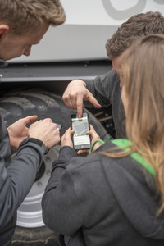 | 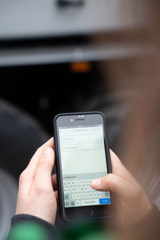
The new HARVEST ASSIST app features now available | New machine category: Other machines
https://www.poettinger.at/de_at/newsroom/pressebild/123749 | https://www.poettinger.at/de_at/newsroom/pressebild/123098
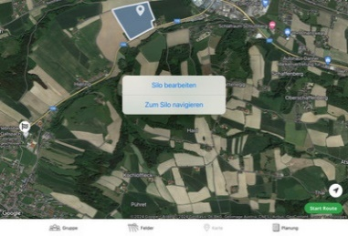 | 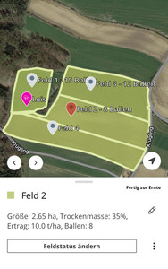
Navigate to the clamp or to the field | Bale overview in the field, makes it even easier to plan your work!
https://www.poettinger.at/de_at/newsroom/pressebild/126733 | https://www.poettinger.at/de_at/newsroom/pressebild/126732

More printer-optimised photos:
www.poettinger.at/downloadcenter

